Session 2018-2019
- A
- Describe RAID working mechanism.
RAID works by placing data on multiple disks and allowing input/output (I/O) operations to overlap in a balanced way, improving performance. Because using multiple disks increases the mean time between failures, storing data redundantly also increases fault tolerance.
RAID arrays appear to the operating system (OS) as a single logical drive.
RAID employs the techniques of disk mirroring or disk striping. Mirroring will copy identical data onto more than one drive. Striping partitions help spread data over multiple disk drives. Each drive's storage space is divided into units ranging from a sector of 512 bytes up to several megabytes. The stripes of all the disks are interleaved and addressed in order. Disk mirroring and disk striping can also be combined in a RAID array.
- “If a large number of devices are connected to the buses, performance will suffer”-explain this statement. Distinguish among local bus, system bus and expansion bus.
If a great number of devices are connected to the bus, performance will suffer. There are two main causes: In general, the more devices attached to the bus, the greater the bus length and hence the greater the propagation delay. This delay determines the time it takes for devices to coordinate the use of the bus.
Aspect | Local bus | System bus | Expansion bus
Location | Inside the CPU | Connects CPU to RAM | Connects peripherals
Function | Data transfer within CPU | Communication between CPU and RAM | Connects peripheral devices like GPUs, storage and expansion cards
Speed | Very high speed | High speed | Slower than system bus
Components | Connects CPU to cache | Consists of data bus, address bus and control bus | Connects to peripheral slots on the motherboard.
Data width | Typically 64 bits or more. | Varies (32, 64 or more bits) | Varies (32 or 64 bits)
Examples | Front-side Bus (FSB) | Memory bus, System Bus | PCI and PCIe.
- Give the characteristics of RISC and CISC.
- RISC (Reduced Instruction Set Computer) Characteristics:
  - It has simpler instructions and thus simple instruction decoding.
  - More general-purpose registers.
  - The instruction takes one clock cycle in order to get executed.
  - The instruction comes under the size of a single word.
  - Pipeline can be easily achieved.
  - Few data types.
  - Simpler addressing modes.
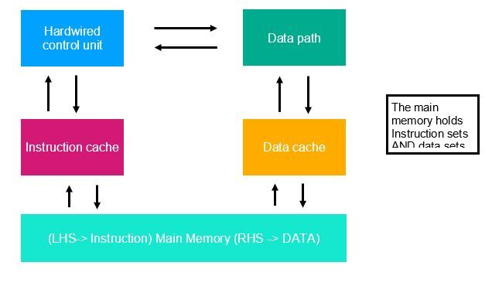
- CISC (Complex instruction Set Computer) Characteristics:
  - Instructions are complex, and thus it has complex instruction decoding.
  - The instructions may take more than one clock cycle in order to get executed.
  - The instruction is larger than one-word size.
  - Lesser general-purpose registers since the operations get performed only in the memory.
  - More data types.
  - Complex addressing modes.
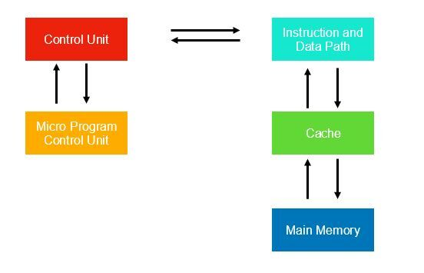
- Describe about set associative mapping. Give the replacement algorithms in cache memory.
- Set-associative mapping allows each word that is present in the cache can have two or more words in the main memory for the same index address. Set associative cache mapping combines the best of direct and associative cache mapping techniques. In set associative mapping the index bits are given by the set offset bits.
- Replacement algorithms:
- FIFO (First-In, First-Out): Replace the oldest item.
Cache: [ ][ ]
Access M1:
Cache: [M1][ ]
Access M2:
Cache: [M1][M2]
Access M3 (Replacing M1):
Cache: [M3][M2]

- LRU (Least Recently Used): Replace the least recently accessed item.
Visual:
Cache: [ ][ ]
Access M1:
Cache: [M1][ ]
Access M2:
Cache: [M1][M2]
Access M1 (Promoting it as most recently used):
Cache: [M2][M1]
Access M3 (Replacing M2 as least recently used):
Cache: [M3][M1]

- LFU (Least Frequently Used): Replace the item with the fewest accesses.
Visual:
Cache: [ ][ ]
Access M1:
Cache: [M1][ ]
Access M2:
Cache: [M1][M2]
Access M1 (Incrementing its access count):
Cache: [M2][M1][ ][ ]
Access M3 (Replacing M2 as least frequently used):
Cache: [M3][M1]

- Shortly explain the working mechanism of operating system to interact user with computer hardware.
The operating system (OS) serves as a bridge between users and computer hardware by:
- Abstracting Hardware: It hides complex hardware details, presenting a standardized interface to applications.
- Resource Management: It allocates CPU, memory, and devices to applications, ensuring fair and efficient resource usage.
- User Interface: It provides a user-friendly interface (GUI/CLI) for users to interact with the computer.
- Device Handling: It manages hardware devices, handling input/output and device driver communication.
- Security: It enforces security measures, controls access, and protects against threats.
- Find out the quotient and reminder by performing twos complement division operation where divisor=-3 and dividend=-7
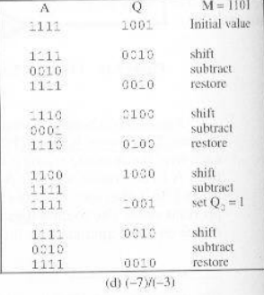
- Define Random Access Memory (RAM). Distinguish between two’s complement division operation where divisor=-3 and dividend=-7.
RAM (random access memory) is a computer's short-term memory, where the data that the processor is currently using is stored.
- Consider a machine with a byte addressable main memory of 2¹⁶ bytes and block size of 8 bytes. Assume that a direct mapped cache consisting of 2 lines is used with this machine.
- How is a 16-bit memory address divided into tag, line number and byte number?
8 leftmost bits = tag; 5 middle bits = line number; 3 rightmost bits = byte
number
- Into what line would bytes with each of the following addresses be stored?
- 0001 0001 0001 1011
slot 3;
- 1100 0011 0011 0100
slot 6;
- How many total bytes of memory can be stored in the cache?
Bytes with addresses 0001 1010 0001 1000 through 0001 1010 0001 1111 are stored in the cache

- Distinguish between program driven and interrupt driven I/O.
Aspect | Program-Driven I/O | Interrupt-Driven I/O
Triggering Mechanism | Initiated explicitly by the program. | Initiated by hardware interrupts.
CPU Involvement | Consumes CPU cycles while waiting for I/O to complete. | CPU can be freed for other tasks while waiting for I/O completion.
Responsiveness | Potentially slower response time due to CPU waiting. | Typically faster response time as the CPU is not waiting.
CPU Overhead | Higher CPU overhead as it must actively manage I/O operations. | Lower CPU overhead as the CPU is released during I/O operations.
Examples | Reading/writing files using standard input/output functions. | Handling hardware interrupts like keyboard input or network packets.

b)
- Illustrate and list the micro-operations to perform addition between two operands from memory.
Let us consider an example for clear understanding of Micro-Operations:
Consider an ADD instruction:
ADD R1, X
Which adds the contents of the location X to register R1. The following sequence of micro-operations might occur:
t₁: MAR{IR:(address)}
t₂: MBRMemory
t₃: R1{R1}+{MBR}
we begin with the IR containing the ADD instruction.
- In the first step, the address portion of the IR is loaded into the MAR.
- Then the referenced memory location is read.
- Finally, the contents of R1 and MBR are added by the ALU
- Assume numbers are represented in 6-bit two’s complemented representation. Show calculation of the following: -1A+2B(Hex)
1A=011010
1A=100110 (After 2’s Complement)
2B=101011
-------------------------
11=010001
- Why I/O module is used in computer system? Classify the external devices.
- An I/O module is required to perform activities, such as decoding and accepting commands, reporting status updates, and recognizing its own address, in order to complete processor communication. Regulates data transfer between external devices and the main memory or the CPU register and external devices.
- External devices:
- Human Readable Devices:
- They allow users to input information or receive output in a format that is easily understood by people.
- Examples include:
- Keyboards and Mice: Input devices that allow users to type text or control the cursor.
- Monitors and Displays: Output devices that present visual information and graphics.
- Touchscreens: Interactive displays that enable users to directly interact with the interface.
- Machine Readable Devices:
- They produce or interpret data in a format that is suitable for automated processing by computers.
- Examples include:
- Barcode Scanners: Devices that read barcodes for inventory tracking and retail.
- RFID (Radio-Frequency Identification) Readers: Used for automated identification and tracking.
- Communication Devices:
- They enable data transmission, reception, and networking capabilities.
- Examples include:
- Network Adapters: Enable connectivity to wired or wireless networks.
- Modems: Convert digital data into analog signals for transmission over telephone lines.
- Routers: Manage data traffic and direct it to its destination in computer networks.
- Bluetooth and Wi-Fi Modules: Enable wireless communication between devices.
- Write short notes (any two):
- Dual core.
- A dual-core processor is a type of CPU (Central Processing Unit) that contains two independent processing cores (or CPUs) within a single physical chip.
- Each core can execute instructions and perform tasks independently, which can improve multitasking and overall system performance.
- Dual-core processors are commonly found in computers and laptops and are suitable for everyday computing tasks, such as web browsing, office applications, and multimedia playback.
- Pentium.
- Pentium is a brand of microprocessors developed by Intel, one of the world's leading semiconductor manufacturers.
- The Pentium series has been a prominent part of Intel's CPU lineup for many years, starting with the original Pentium processor released in 1993.
- Pentium processors are known for their versatility and have been used in a wide range of computing devices, including desktops, laptops, and budget-friendly systems
- Core i7.
- Core i7 is a brand of high-performance processors manufactured by Intel.
- It is part of Intel's Core series, which includes various processor families designed for different performance levels.
- Core i7 processors are typically found in high-end desktops, workstations, and gaming laptops, offering excellent performance for power users and professionals

- What, in general terms, is the distinction between computer organization and computer architecture? List and briefly define the main structural components of a computer.
- Distinction between CO and CA.
- Computer architecture refers to the attributes visible to the programmer and which affect the logical execution of a program.
- Computer organization refers to the hardware units that realize the architecture: the instruction set, the number of bits used to represent data types, addressing memory, etc.
- Main structural components of a computer:
- CPU: Controls the operation of the computer and performs its data processing functions.
- Main memory: Stores data.
- I/O: Moves data between the computer and its external environment.
- System interconnection: Some mechanism (e.g. a system bus) that provides for communication among CPU, main memory, and I/O.
- Explain Moore’s law. On the IAS, describe the process that the CPU must undertake to read a value from memory and to write a value to memory in terms of what is put into the MAR, MBR, address bus, data bus and control bus.
- Moore's Law states that the number of transistors on a microchip doubles every two years. The law claims that we can expect the speed and capability of our computers to increase every two years because of this, yet we will pay less for them.

- For read a value from memory, CPU will put the address of the value it wants into MAR and asserts the read control line to memory in order to place the address on the address bus. Memory will place the contents of memory location passed on the data bus and then transferred to MBR. For write a value to memory, CPU have to put the address of the value it want to write into MAR. CPU will put the data it want to write into MBR Then CPU will run the write control line to memory and places the address on the address bus and data on the data bus. Then only memory will transfers the data on the data bus into the corresponding memory location
- What are the key properties of semiconductor memory? What is the difference between DRAM and SRAM in terms of characteristics.
- Key properties of semiconductor memory:
- Stores data in magnetic form.
- Affected by magnetic fields.
- Has high storage capacity.
- Doesn't use a laser to read/write data.
- Magnetic storage devices are; Hard disk, Floppy disk, Magnetic tape etc.
- SRAM VS DRAM
SRAM | DRAM
It can store data as long as electricity is available. | It saves data for as long as the power is on or for a few moments if the power is turned off.
SRAM has a storage capacity of 1 MB to 16 MB in most cases. | DRAM, which is often found in tablets and smartphones, has a capacity of 1 GB to 2 GB.
The storage capacity of SRAM is low. | The storage capacity of DRAM is higher than SRAM.
SRAM is more expensive than DRAM. | DRAM is less expensive than SRAM.
It is comparatively faster. | It is comparatively slower.
SRAM is used in cache memories. | DRAM is used in main memories.

- Define memory cell, Describe the structure of a typical memory cell.
- A memory cell is a small unit of storage in a computer's memory, typically used to store a single byte of data.
- Today, the most common memory cell architecture is MOS memory, which consists of metal–oxide–semiconductor (MOS) memory cells. Modern random-access memory (RAM) uses MOS field-effect transistors (MOSFETs) as flip-flops, along with MOS capacitors for certain types of RAM.

- What is clip logic? Describe a 16 Megabit DRAM (4M x 4) memory structure.
Logic clips, as shown in below figure, are spring-loaded devices that are designed to clip onto a dual-in-line package IC while the IC is mounted in its circuit.
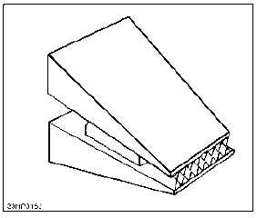
Typical 16 Mb DRAM (4M x 4) – details 4 bits are read and written at a time. Memory array is organized as 4 square arrays of 2048 x 2048 elements. Elements are connected by both horizontal (rows) and vertical (columns) line. Each horizontal line connects to the Select terminal of each cell in its row. Each vertical line connects to data in/sense terminal of each cell in its column.
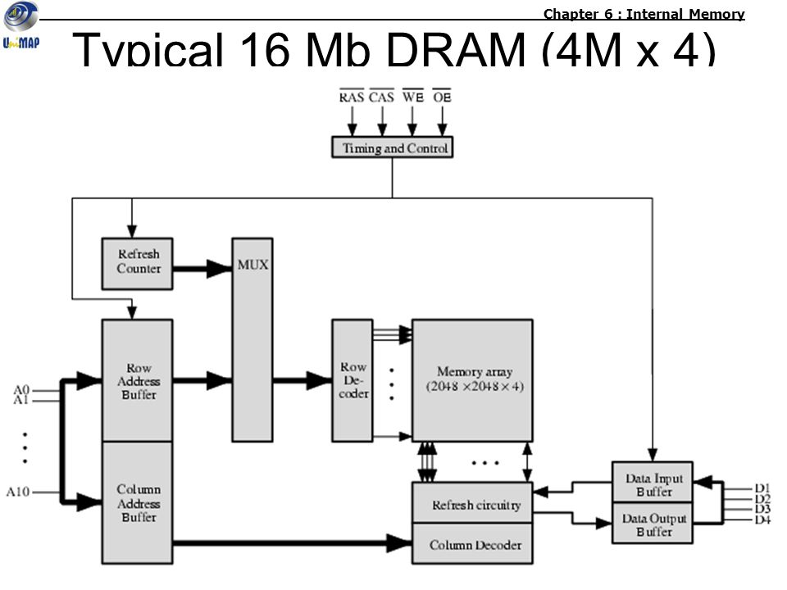
- How error-correcting code works? Describe the Hamming Error-correcting code procedure.
- An error correcting code (ECC) is an encoding scheme that transmits messages as binary numbers, in such a way that the message can be recovered even if some bits are erroneously flipped. They are used in practically all cases of message transmission, especially in data storage where ECCs defend against data corruption.
- Hamming error-correcting code procedure:
- Add extra "parity" bits to your data.
- Position parity bits at powers of 2 (1, 2, 4, 8, etc.).
- Calculate parity bit values based on data bits.
- Transmit data with parity bits.
- Receiver checks parity bits for errors.
- If errors detected, correct them using parity bits.
- If multiple errors occur, detect but can't correct.

- Write down the elements of a machine instruction. Draw and describe the instruction cycle state Diagram.
- Elements of a machine instruction:
- Opcode. (specifies the op. to be performed.)
- Source and destination operand references. (specify the input and output locations for the op.)
- Next instruction references. (Which is usually implicit)
- In the basic computer, each instruction cycle includes the following procedures-
- It can fetch instruction from memory.
- It is used to decode the instruction.
- It can read the effective address from memory if the instruction has an indirect address.
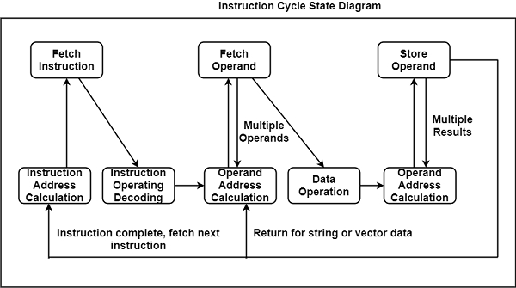
- It can execute the instruction.

- Describe about Nested Procedures. What is the difference between arithmetic shift and logical shift?
- Nested procedures (PROC) are a technique to create a PROC that contains a call to another PROC. This process is useful when a particular set of JCL statements is needed in multiple procedures. It is easier to define them in a separate procedure than to repeat them in each one. Procedures can be nested up to 15 levels.

- Difference between arithmetic shift and logical shift:
Aspects | Arithmetic shift | Logical shift
Purpose | Preserves the sign of the number | Fills shifted-out bits with zero.
Shifting direction | Right shift extends sign bits. | Right shift always pads with zeros.
Effect on sign bit | Sign bit stays the same | Sign bit is set to 0
Effect on magnitude | Magnitude may change due to sign. | Magnitude always remains the same.
Use cases | Used in signed number operations. | Used for logical operations.

- Define register addressing. Describe the x86 instruction formats.
- In register addressing, the operand is placed in one of 8 bit or 16 bit general purpose registers.
- Example: MOV AX,CX (move the contents of CX register to AX register)
- x86 instruction formats
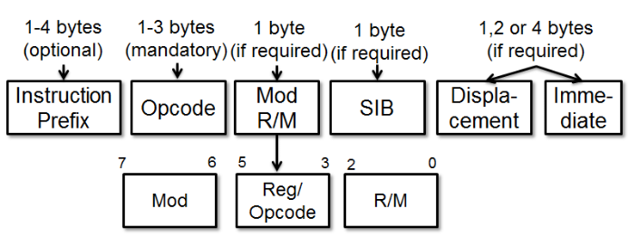
- What is user -visible registers? Draw the internal structure of the CPU.
- A user visible register (UVR) are the registers that are directly accessible by the programmer.

- Internal structure of the CPU:
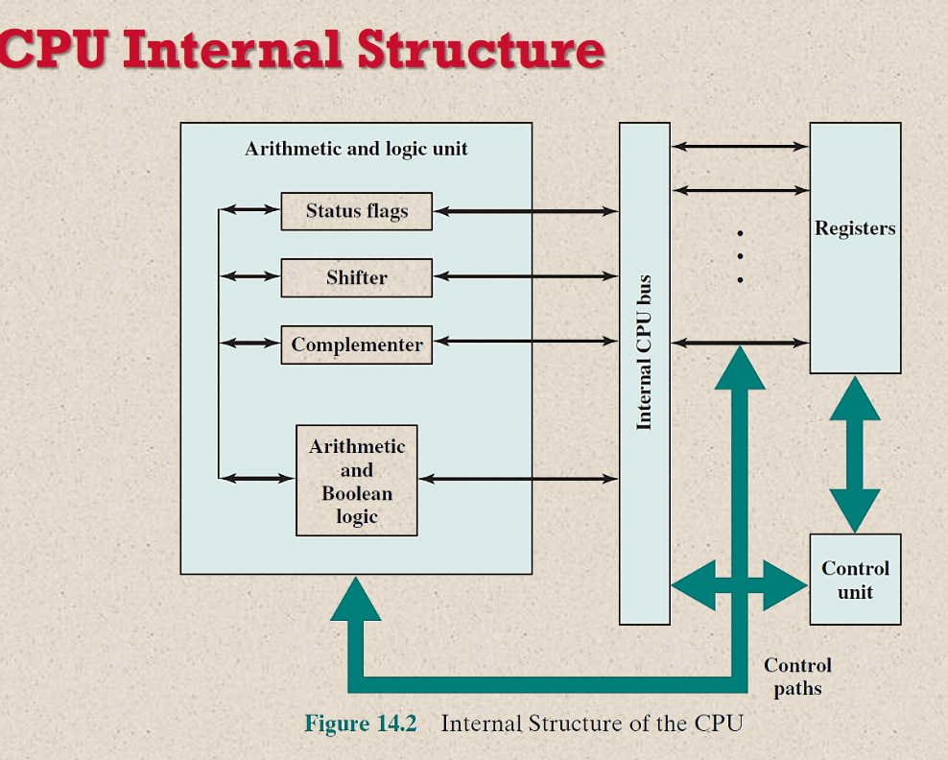
- Write down the control and status registers. Describe the data flow of fetch and indirect cycle.
The control and status registers refer to byte addressing as seen by the software, and as implemented by hardware. All registers that are Read-Writable must be protected to comply with Security Development Lifecycle (SDL) practices.
- Fetch and Indirect Cycle Data Flow:
- Fetch Cycle:
- Instruction fetch from memory.
- Program Counter (PC) holds the memory address.
- Data is loaded into Instruction Register (IR).
- PC incremented for the next instruction.
- Indirect Cycle (if needed):
- If the instruction involves indirect addressing:
- Address calculation using the IR.
- Fetch data from the calculated address.
- Data loaded into a register for further processing.

- What is instruction pipelining? Describe the Six-stage CPU instruction pipelining with timing diagram.
- An instruction pipeline reads instruction from the memory while previous instructions are being executed in other segments of the pipeline
- In general, each and every instruction must be processed by the computer in the following order:
- Fetching the instruction from memory
- Decoding the obtained instruction
- Calculating the effective address
- Fetching the operands from the given memory
- Execution of the instruction
- Storing the result in a proper place
Each step is carried out in its own segment, and various segments may take different amounts of time to process the incoming data. Furthermore, there are occasions when multiple segments request memory access at the very same time, requiring one segment to wait unless and until the memory access of another is completed.
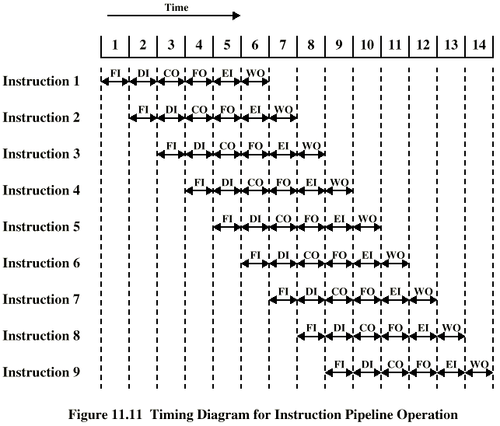

Session 2017-2018(Selective)
- A. Why you need to study COA? (Also answer for learning outcome of COA)
- System Understanding: Gain insights into the organization and functioning of computer systems.
- Efficient Programming: Write more efficient code by understanding hardware execution and memory access.
- Hardware-Software Interface: Bridge the gap between high-level programming languages and machine code.
- System Design and Optimization: Design and optimize computer systems for specific needs.
- Performance Evaluation: Evaluate and improve system performance through COA principles.
- Computer Engineering Roles: Foundation for success in computer engineering, hardware design, and architecture.
- C) How does Cache speed up the CPU Performance?
Cache speeds up CPU performance by storing frequently used data and instructions close to the processor. This minimizes the time the CPU spends waiting for data from slower main memory. Cache takes advantage of the fact that programs often reuse the same data, providing quicker access to frequently needed information. This helps reduce memory access latency, optimize instruction fetching, and improve overall CPU efficiency.
- How can you characterize the memory of your computer?
In general, memory can be divided into primary and secondary memory; moreover, there are numerous types of memory when discussing just primary memory. Some types of primary memory include the following
- Cache memory: This temporary storage area, known as a cache, is more readily available to the processor than the computer's main memory source.
- RAM: The term is based on the fact that any storage location can be accessed directly by the processor.
- Dynamic RAM: DRAM is a type of semiconductor memory that is typically used by the data or program code needed by a computer processor to function.
- Static RAM: SRAM retains data bits in its memory for as long as power is supplied to it. Unlike DRAM, which stores bits in cells consisting of a capacitor and a transistor, SRAM does not have to be periodically refreshed.
- Double Data Rate SDRAM: DDR SRAM is SDRAM that can theoretically improve memory clock speed to at least 200 MHz.

- C. Explain different types of operation. Perform arithmetic left shift(10100110) for 3 bits and Right Rotate (10100110) for 3 bits.
- Different types of operation
- Data transfer.
- Arithmetic.
- Logical
- Conversion
- I/O
- System control.
- 00110000(3-bit left shift)
- 11010100(3-bit right rotate)
- A) What do you mean by variable length addressing? Why is it necessary?
Variable-length addressing refers to a memory addressing scheme where data elements or instructions may occupy varying amounts of memory. It allows efficient use of memory by adapting to the size of individual data items or instructions, reducing wasted space. This flexibility is necessary for managing diverse data structures and optimizing memory utilization in programming.
C) ”Each operation needs operand”-Justify this statement. Briefly describe various categories of operand.
The statement "Each operation needs operand" means that in any computer operation or instruction, there must be data to act upon. An operand is the data that an operation works with. Here are various categories of operands:
- Immediate Operand: Data or a constant value is directly specified within the instruction.
- Register Operand: Data is stored in a processor register.
- Memory Operand: Data is fetched from or stored to a memory location.
- Register-Indirect Operand: The operand contains the address of a register where the actual data is stored.
- C) Describe pipelining. “Pipeline processor with k stages is k time faster than non-pipeline processor”-Justify this statement. (Book: Page-430)

Session 2015-2016(Selective)
- A) Explain the distinction between the written sequence and time sequence of an instruction.
Time sequence of instruction cycles is not necessarily the same as the written sequence of instructions that make up the program, because of the existence of branching
instructions.
The actual execution of instructions follows a time sequence of instructions.
C) Why error correction is needed in memory system?
Error correction codes protect against undetected data corruption and are used in computers where such corruption is unacceptable, examples being scientific and financial computing applications, or in database and file servers.
- a) Describe the elements of a machine instruction.
- Opcode. (specifies the op. to be performed.)
- Source and destination operand references. (specify the input and output locations for the op.)
- Next instruction references. (which is usually implicit)
b) Enlist different addressing mode.
- Implied Mode.
- Immediate Mode.
- Register Mode.
- Register Indirect Mode.
- Autodecrement Mode.
- Autoincrement Mode.
- Direct Address Mode.
- Indirect Address Mode.
- a) Why Input/output module is used in computer system? Describe the functions.
Input/ Output Modules, or I/O Modules, manage the communication between a CPU and a network, including the transfer of data, the management of power loads, and the control of machine functions.
This enables system integrators to connect disparate devices, allowing greater control of the industrial network.

